Document Information
Project name: | Overwatch
Date:
Author: | Jesper Petersen
Approver: | Francois Allard, Jesper Petersen, Henrik Poulsen, Anette Hermansen, Vivian Hæk, Helle Larsen
Document code: | 1
Version: | 1.0

Note: this document may not be valid anymore. Please check the configuration management system for the latest approved version of the document.

‘

Approval
Date | Name | Signature
 | Francois Allard
 | Jesper Petersen
 | Henrik Poulsen
 | Anette Hermansen
 | Vivian Hæk
 | Helle Larsen

Notes

Objectives
 | Reference
Scope | Business case
Time | Business case
Cost | Business case
Quality | Quality management
Risks | Risk management
Benefits | Business case

Products
Product Name | Product Description
Applikation | Reference til applikation produkt beskrivelse
Overvågeings module | Reference til overvågeings module produkt beskrivelse
Central server | Reference til central server produkt beskrivelse

Monitoring and Control
Reference til Configuration management strategy

Prerequisites, Assumptions, and External Dependencies
- Lovgivning
- Market
- Pris
- Tid
- Ressourcer

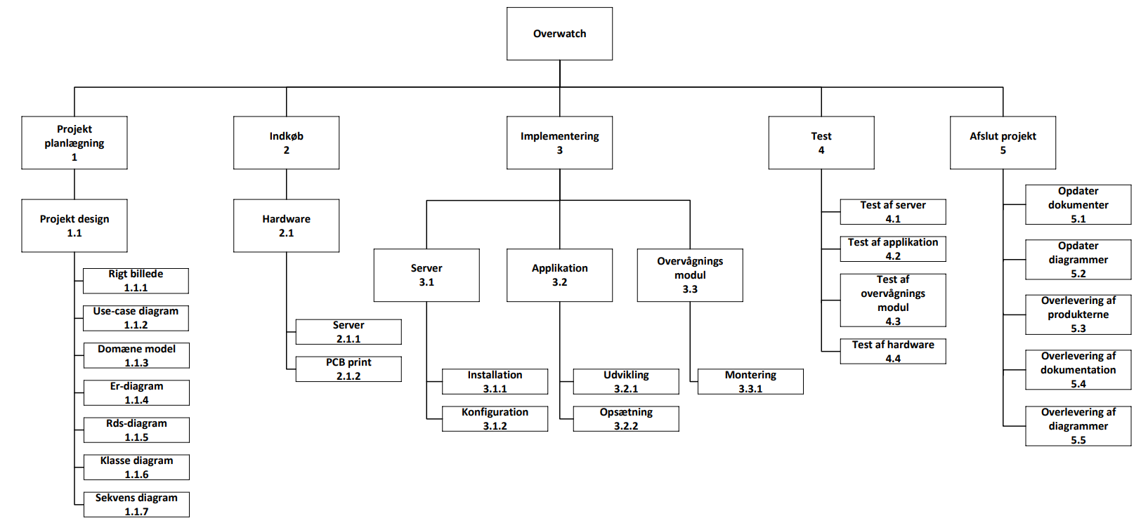
Schedule / WBS

Lessons Incorporated
Lesson Learned

